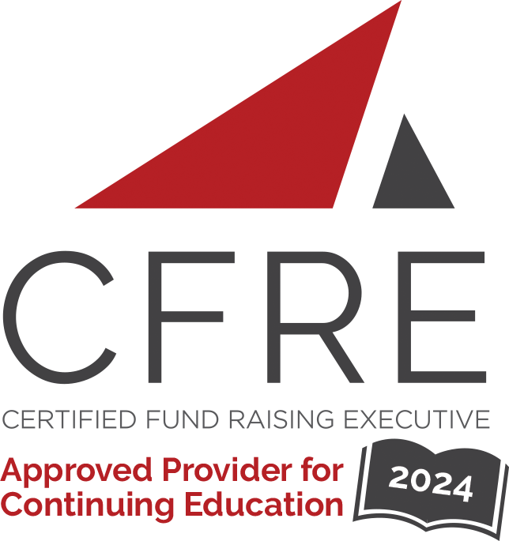  CFRE International has developed this form as a way for you to quickly track (and keep in your files!) the continuing education sessions you have attended. Simply check the boxes next to the sessions you attended. At the end of the conference, add up the total number of hours. Keep this sheet and you will be ready to complete your application form. All of the session slots listed are eligible for continuing education points on your CFRE application for initial certification and/or recertification. Sessions not listed here are not eligible for points. |  | CONTINUING EDUCATION POINTS TRACKER

Activity Organizer: - NTEN
Title of Activity: - 2024 Nonprofit Technology Conference (24NTC)
Names of Presenter(s): - Various
Dates and Location: - March 13-15, 2024, Portland, OR

Date: Wednesday, March 13, 2024
Session 1: 10:15 [am] – 11:15 [am] (1 pt)
- [Accelerating Nonprofit Communications: Draft, Refine, And Personalize With AI]
- [Artificial Intelligence Readiness To Enhance Equitable Outcomes]
- [Big Budget Tech Transformation: Making Massive Projects Manageable]
- [Bridging Beyond Broadband: An Innovative Solution To Digital Inclusion]
- [Community Catalysts: Designing Equitable Technology Donation Programs]
- [Cyber Incident Prep And What We Can Learn From Real-World Incidents]
- [Digital Transformation: Build An Analytics Roadmap That Works For Your Org]
- [Embedded Ethical And Responsible Use: Generative AI And Nonprofit Work]
- [Employee Benefits, Motivation, And Feedback: A Basic Guide To Measure And Adjust]
- [Harnessing Conflict And Intuition In Product Strategy And Development]
- [How Nonprofits Can Work With Influencers To Reach New Audiences]
- [Increasing Subscriber Diversity At Legacy Nonprofits]
- [Making The Most Of Your Cybersecurity Budget]
- [Proactive Data And Privacy Protection For Vulnerable Populations]
- [Unlocking Better Technology Collaborations Through User Stories]
- [What Drives Donations: Real Lessons For Effective Fundraising On Social Media]
- [When Automations Attack! Cautionary Tales And Pitfalls To Avoid]
- [The Transformative Role Of People-Centric And Trauma-Informed Leadership]
- [Test Your Website's Accessibility Starting…Now!]
- [Strengthening Organizational Culture Through Intergenerational Communication]

Date: Wednesday, March 13, 2024
Session 2: 1:15 [pm] – 2:15 [pm] (1 pt)
- [5 Levels Of A MEL Data Flow: From Field To Funder, From Input To Insights]
- [Accelerators, Incubators, And Fellowships: Building Capacity Via Cohort Programs]
- [Care And Feeding Of Your Constituent Relationship Management Platform]
- [Build Engagement With NTEN Tech Clubs]
- [Avoid Technical Debt From Killing Your Nonprofit]
- [A Little More Privacy, Please: Diving Into Data Privacy For Nonprofits]
- [Board Engagement Breakthroughs With Technology]
- [Cultivating A Data-Informed Learning Culture In Your Organization]
- [Dynamite Data Dashboards]
- [Use Your Tech To Enable Generosity]
- [The Giving Brain: The Neuroscience Of Planned Giving]
- [The Secret To Loyal Donors: Email Welcome Journeys]
- [Technology Implementation: Creating Buy-In From Non-Technical Staff]
- [Push The Right Buttons: Elevate Your Email Game With Compelling Calls To Action]
- [Introducing An Artificial Intelligence Adoption Framework For An Equitable World]
- [Get Your Nonprofit In Tech-Top Shape: Leading Technology And Change Management]
- [Get Your Nonprofit In Tech-Top Shape: Leading Technology And Change Management]
- [Get Your Website Ready To Advertise]

Date: Thursday, March 14, 2024
Session 1: 10:15 [am] – 11:15 [am] (1 pts)
- [A Process To Be Proud Of: Working Equity Into Your Hiring]
- [Artificial Intelligence Is Here: Are You Using It?]
- [Captivating Community Champions To Donate With Maps]
- [Data-Driven Marketing Strategies: How To Make Informed Choices To Drive Impact]
- [Data Governance Made Fun And Easy]
- [Don’t Close The Door On Your Donors: Intentionally Inclusive Fundraising Events]
- [Generative Artificial Intelligence Uses For Electoral Organizing]
- [How To Integrate Artificial Intelligence Into Workflows For Greater Impact]
- [Level Up Your Planned Giving: How To Fill And Cultivate Your Legacy Pipeline]
- [Liberatory Innovation: Abolitionist Approaches To Technical Problem Solving]
- [Matching Gifts 101, 201, 301]
- [Prompt Engineering For Beginners: Use AI For Better, Faster Communications]
- [Responsible Use Of The Internet In The Age Of Artificial Intelligence]
- [Towards A More Ethical Approach To Using Artificial Intelligence For Creative]
- [Using Public Data To Design Products And Programs Inclusive To Immigrants]
- [What Is White Supremacy Culture?]
- [Why And How To Switch To A Four-Day Work Week]

Date: Thursday, March 14, 2024
Session 2: 2:00 [pm] – 3:00 [pm] (1 pt)
- [Are You Digital Campaigns Susceptible To Bot, Spam, And Fraud Traffic]
- [Building A Sustainable Grassroots Recurring Donor Program]
- [Centering Community In Your Organization's Artificial Intelligence Journey]
- [Connecting Connected TV To Your Bottom-Line Results]
- [Countering Disinformation: Lessons And Best Practices]
- [Creating Inclusive And Welcoming Online Spaces From Beginning To End]
- [Don’t Let Your Team’s Personally-Identifiable Info Compromise Your Hard Work]
- [Encouraging Discovery And Exploration On Content-Heavy Websites]
- [Hands On With Artificial Intelligence For Both Fundraising Story And Data]
- [Live, Laugh, And Love During Your Sustainer Donor Migration]
- [Navigating Executive Transitions: Leveraging Change For Innovation]
- [Practical Guide To Using Artificial Intelligence Without The Pitfalls]
- [Strategic Synergy: Integrating Operations For Organizational Success]
- [The Essential Craft Of Leaving Your Job]
- [Top 10 Automations Every Nonprofit Should Have]
- [Things We Wish Our White Colleagues Knew]
- [Unlocking Potential: Equity In Tech Through Fair Chance Hiring]
- [Where Should I Meet You? Conversations On When, Where, And How To Deploy Tech]

Date: Friday, March 15, 2024
Session 1: 10:15 [am] – 11:15 [am] (1 pts)
- [Centering Community Voices: Using Virtual Focus Groups To Get Community Feedback]
- [Consultant Or In-House: Internal Assessments Before Hiring An Expert]
- [Creators For Change: Unlocking The Potential Of Social Influencers]
- [Equitable Governance And Consent-Based Decision-Making: An Intro To Sociocracy]
- [How To Revamp Your Social Strategy Amid The Chaos]
- [How To Store, Protect, And Use Your Organization's Data Effectively]
- [Improving Accessibility In Nonprofit Workplaces]
- [Inclusive Data Literacy In A Diverse Organization]
- [Lessons Learned Converting To A Community-Centered Fundraising Messaging Model]
- [Linguistic Justice With Multilingual Websites]
- [Navigating Change With Purpose: Change Management In Nonprofit Operations]
- [Predictably Irrational: Using Decision Science To Improve Fundraising]
- [The Future Of Impact Reporting: Practical Solutions For Current Challenges]
- [Toward A More Digitally Inclusive Domain Name System]
- [Using Feedback Loops To Strengthen Programs And Relationships]
- [Website Analytics: What Strategies Are Working For Everyone Else Right Now]

Total number of points attained: __________

